|  |  |  |  |
| --- | --- | --- | --- |
| **Tuần 2 :**  **Tiết 3 ( 13/9/2021-18/9/2021)**  **I. Speak:** | | | |
| **VOCABULARY** |  |  |  |
| 1. introduce | (v) | /ˌɪntrəˈdjuːs/ | giới thiệu |
| → | (n) | /ˌɪntrəˈdʌkʃn/ | sự giới thiệu |
| 2. industry | (n) | /ˈɪndəstri/ | công nghiệp |
| → | (a) | /ɪnˈdʌstriəl/ | thuộc công nghiệp |
| → | (v) | /ɪnˈdʌstriəlaɪz/ | công nghiệp hóa |
| 3. It's up to you |  |  | tùy bạn |
|  |  |  |  |

|  |  |
| --- | --- |
| 1. Hello. You must be Maryam 2. Do you live in a city, too? 3. No. Is it very different from Ha Noi? 4. Yes, I am. Are you enjoying your stay in Vietnam? 5. Pleased to meet you.Let me introduce myself, I'm Nga. 6. I see. Oh! Here's Lan. Let's go. | 1. The two cities are the same in some ways. 2. Pleased to meet you, Nga. Are you one of Lan's classmates? 3. That's right, I am. 4. Oh, yes, very much. Vietnamese people are very friendly and Ha Noi is a very interesting city. 5. Yes. I live in Kuala Lumpur. Have you been there? |

|  |  |
| --- | --- |
| **1.** **A:** Hello. You must be Maryam | **c.** **B:** That's right, I am. |
| **5.** **A:** Pleased to meet you.  Let me introduce myself, I'm Nga. | **b.** **B:** Pleased to meet you, Nga. Are you one of Lan's classmates? |
| **4.** **A:** Yes, I am. Are you enjoying your stay in Vietnam? | **d.** **B:** Oh, yes, very much. Vietnamese people are very friendly and Ha Noi is a very interesting city. |
| **2.** **A:** Do you live in a city, too? | **e.** **B:** Yes. I live in Kuala Lumpur. Have you been there? |
| **3.** **A:** No. Is it very different from Ha Noi? | **a.** **B:** The two cities are the same in some ways. |
| **6.** **A:** I see. Oh! Here's Lan. Let's go. |  |

**II. Listen:**

***\*New words:***

- hamburger (n):

***Tim Jones’s Mexican pen pal, Carlo, is visiting the USA. Listen to their conversation and check (v) the numbers of the correct pictures.***

**a)** 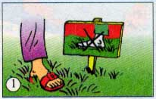 

**A.Don’t walk on the grass**

**B.Don’t pick the flower**

**b)** 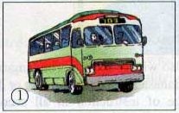 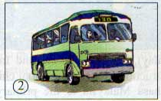

**A.The bus number 103**

**B.The bus number 130**

**c)**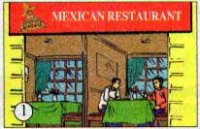 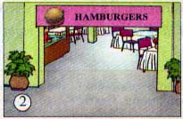

**A.Hamburgers**

**B.Mexican restaurant**

**Exercise: ( Bài tập thêm)**

**.*Listen and Fill in the blank**

Tim: Are you hungry, Carlo?

Carlo: Yes.

Tim: Okay. Let’s go to a restaurant downtown. If we go through the(1)……………, we can catch a bus on Ocean Drive.

Carlo: That’s fine. I really like ( 2)………….in the park. You `re lucky to have a place like this close to your home. It`s so ( 3)……………with all the trees and flowers and a pond in the middle.

Tim: Carlo! Be careful. You`re walking on the grass. The (4)………….is growing some more - you’ll kill the new grass.

Carlo: Oh, sorry. I didn`t see the sign.

Tim: Come on. It`s time we (5)………………the bus.

Carlo: Is that our bus, Tim?

Tim: No. That`s a bus 103. We want the number( 6)……………..

Carlo: Where are we going to eat?

Tim: It`s up to you. There’s a new Mexican(7)……………. in town.

Carlo: Oh, no. I can eat Mexican food at home. I love American food. I`d rather eat(8)…………..

Tim: Okay. I know exactly where we need to go.